PRESIDENT’S OFFICE
REGIONAL ADMINISTRATION AND LOCAL GOVERNMENT
FORM IV TAHOSSA NORTH WESTERN ZONE MOCK EXAMINATION 2025

036 INFORMATION AND COMPUTER STUDIES

TIME: 3HOURS AUGUST 2025

INSTRUCTIONS
1. This paper consists of section A, B and C with Eleven (11) Questions
2. Answer all questions in Section A, B and two (2) questions in section C
3. Your work should be clearly Shown.
4. Write your Examination Number on every page
5. Mobile Phone are Not allowed in the examination room

SECTION A
Answer all the questions in section

1. For each of the following items ( i — x), choose the letter of the most correct answer and write it in the table provided below.

i. In DTP, threading to text frame refers to:
A. Ceating different text frames for text
B. Creating one long text frame for all text on a single frame
C. Creating one short text frame for all text on a single frame
D. Creating different interconnected text frames on different pages
ii. Which of the following database objects holds data?
A. Forms
B. Reports
C. Query
D. Tables
iii. Which of the following methods in a database is a short cut to display a record from a table and edit its contents
A. Use find and replace command
B. Filter records to remain with the one you need
C. Use select query to locate the record
D. Select the table and edit its content
iv. Nowdays when people wants to connect to the internet they think of using Google Chrome. This is because
A. It locates and displays world wide web documents
B. It stores web related files
C. It has hypertext document that can be accessed over the world wide web
D. It contains hyperlinks that references to other documents
v. The following actions will save changes to a document that was previously saved with minimum effort
A. Press Ctrl + V on the keybord
B. Press Ctrl + A on the keybord
C. Press Ctrl + C on the keybord
D. Press Ctrl + S on the keybord
vi. How best can a large worksheet be made to fit on the screen without hiding columns, reducing row height or column width?
A. Zoom the worksheet to a lower percentage
B. Zoom the worksheet to the larger percentage
C. Reduce the font size of all the cell contents
D. Print preview the worksheet
vii. An electronic network device that enables a computer to connect to a network is:
A. NIC
B. SWITCH
C. ROUTER
D. HUB
viii. The foolowng query criteria would retrieve records of people who were born between 01/01/2000 and 01/01/2008
A. BETWEEN #1/01/2000# AND #1/01/2008#
B. =BETWEEN #1/01/2000# AND #1/01/2008#
C. BETWEEN #1/01/2000# OR #1/01/2008#
D. =BETWEEN #1/01/2000# OR #1/01/2008#
ix. A type of computer network topology that consists of all nodes connected to the central device is known as
A. Bus topology
B. Star topology
C. Ring topology
D. Mesh topology
x. Point out the best way to print a chart that is embedded on a worksheet without printing cell entries.
A. Highlight the worksheet then print
B. Click the chart to select it then print
C. Click theprint command then select print
D. Click print preview then select print

2. Match the items found in column A with their proper response found in column B in the apace provided below.
Column A | Column B
- Fraud  - Hacking  - Cyber stalking  - Eaves dropping  - Invasion of privacy  - Phishing | - A fraudulent action that attempts to obtain sensitive information such as username, password and credit card details by using fake phone, email, website or text message  - The act of someone attempting to intrude on someone else’s personal life  - This is an act of taping into communication channel to get information secretly  - This is the unlawful download, use or dissemination of copyrighted material without the permission of the owner  - The use of social media or any other Internet applications or any electronic device to harass an individual, group or organization  - An act of gaining unauthorized access to information for malicious reasons or any other purpose  - This is an act of stealing by false pretend.

SECTION B
Answer all questions
3.Here below are several scenario-based questions related to different computer problems, with each question asking what the problem is and how it can be resolved:
- Your computer has been running significantly slower than usual, taking a long time to open applications and loading web pages. What do you think is causing the slow performance of your computer, and what is the solution to resolve this issue?
- You send a document to your printer, but it remains in the queue and does not print. The printer is on and connected to your network.What might be the problem preventing the printer from responding, and how can you troubleshoot and resolve this issue?
- You are unable to connect to the internet, while other devices in your home seem to be working fine.What are some potential causes of the internet connectivity issue on your device, and what can be done to resolve it?
- You are using a particular software application when it suddenly crashes, and you receive an error message.What do you think could have led to the software crash, and what methods can you use to troubleshoot and resolve this problem?
- You try to open a document that you edited yesterday, but it appears corrupted and unreadable. What could have caused the file corruption, and what measures can you take to attempt recovery or resolve this issue?
4(a)Suppose your geography teacher assign you a task for writing a report concern about form three excursion after visiting Ngorongoro crater. Give three reasons why would use Ms. word to write your report work, instead of typewriter
(b) Briefly describe three common features of word processor
(c) Why is a Desktop Publisher preferred in designing documents than a word
processor? Give at least four reasonsa)

5. You are helping a neighbor to set up their new cable of AZAM dish. They are ensure about which type of cable to use. To give them information about coaxial cable is good compared to twisted cable and you come up with it as the figure shown below. 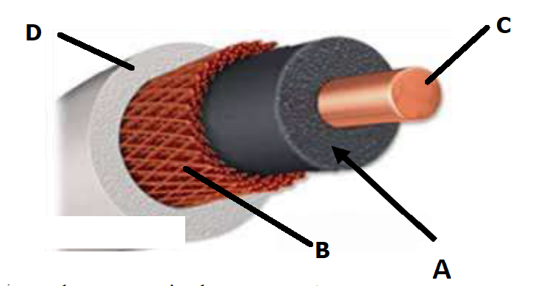
i. State the function of each part labelled A-D
ii. What are the two advantages do coaxial cable offer compared to twisted pair cabling for their AZAM dish installation.
iii. Where do you see coaxial cable fitting into the future of networking?

(b) You are tasked with designing a network for a small office with 10 computers. Each computer needs to access shared resources like printer and files.
i. By drawing sketch up diagram show which type of network topology would you suggest for this setup
ii. Why would it be the most suitable choice (provide two reasons)
6(a)Define what a spreadsheet is and explain the main components of a typical spreadsheet application.
(b) Explain the difference between relative, absolute, and mixed cell references in Excel. Provide examples for each.
(c) Describe the purpose of the following functions in a spreadsheet:
i. SUM
ii. AVERAGE
iii. VLOOKUP
iv. COUNTIF
v. IF
(d) What is conditional formatting in spreadsheets? Explain how it can be applied to highlight cells based on certain criteria. Provide two examples where conditional formatting would be useful.

7.You have been assigned to create an e-mail account for effective communication for your Further studies
a. Which program would you use to accomplish the task?
b. Which steps would you follow to accomplish the task?
c. Briefly explain the use of spam, Carbon copy, and Blind Carbon copy in the electronic mail
8. Mr. Omari wants to invite school committee to discuss the development of the school.
He preferred to use invitation card rather than letter. He needs some help to the following:
(a). Mention two examples of software he can use to create invitation card?
(b). Give three differences between Desktop Publishing and Microsoft Word.
(c). Name any three categories of Desktop Publishing software.

SECTION C
Answer any two questions
9. A small business owner does not understand why they should use a database system. You as an IT expert write a persuasive explanation highlighting five key benefits of database systems and why they are essential for business success.
10. The impact of Computers on modern society is to transform various sectors such as Education, Healthcare, Business and Communication. How does this statement becoming true?

11. The headmaster of mogabiri secondary prefer to use presentations to prepare teaching and learning materials but he is not aware how he can prepare good quality presentation.As a form four student educate him by explaining five characteristics of good presentation.

